TRIBHUVAN UNIVERSITY
INSTITUTE OF SCIENCE AND TECHNOLOGY
Central Department of Computer Science and Information Technology
Kirtipur, Kathmandu



Lab No.: 2
A Lab Report on Implementation of Fuzzy Sets and Operations

Submitted by:
Name: Brihat Ratna Bajracharya
Roll No.: 19/075

Submitted to:
Mr. Jagdish Bhatta
Central Department of Computer Science and Information Technology

Date of submission: 2077 Mangsir 21
LAB 2

Implementation of Fuzzy Sets and Operations
Implement fuzzy sets as discussed in the class. Your program should ask user to input the set elements and corresponding membership values. The program should accept the valid membership values only (0 <= membership value <=1). For the set, use appropriate data structure to store fuzzy element with its corresponding membership value. Also write functions to implement Union, Intersection, Complement, Subset and Alpha Cut operations over the sets. The function corresponding to alpha cut should ask for the alpha value.

Program Code:
'''
Fuzzy Systems Lab 2
Implementation of Fuzzy Sets and Operations
Brihat Ratna Bajracharya (CRN: 19/075)
CDCSIT
'''

from decimal import Decimal as D

def get_fuzzy_tuple():
""" Takes element and value from user to form a tuple """

element = input(' Enter Element: ')
value = float(input(' Enter Membership Value (Range: [0.0, 1.0]): '))

if value < 0.0 or value > 1.0:
print(" Membership Value out of range. (Element will be discarded.")
return

return (element, value)

def get_element(other_set, element):
""" returns element from other_set having same first value as element """

for elem in other_set:
if elem[0] == element[0]:
return elem

return None

def get_union(seta, setb):
""" returns union of seta and setb """

union_set_list = []

for elem in seta:
union_set_list.append([*elem])

for elem in setb:
present = False

if elem[0] in [e[0] for e in seta]:
present = True

if present is True:
old_element = None
for element in union_set_list:
if element[0] == elem[0]:
old_element = element
union_set_list.remove(element)
break
union_set_list.append([elem[0], max(old_element[1], elem[1])])

else:
union_set_list.append([*elem])

union_set = set()
for elem in union_set_list:
union_set.add(tuple(elem))

return union_set

def get_intersection(seta, setb):
""" returns intersection of seta and setb """

intersection_set_list = []

for elem in seta:
intersection_set_list.append([*elem])

for elem in setb:
present = False
if elem[0] in [e[0] for e in intersection_set_list]:
present = True

if present is True:
old_element = None
for element in intersection_set_list:
if element[0] == elem[0]:
old_element = element
intersection_set_list.remove(element)
break

intersection_set_list.append([elem[0],
min(old_element[1], elem[1])])

else:
intersection_set_list.append([elem[0], 0.0])

for elem in intersection_set_list:
if elem[0] not in [e[0] for e in setb]:
elem[1] = 0

intersection_set = set()
for elem in intersection_set_list:
intersection_set.add(tuple(elem))

return intersection_set

def get_complement(seta):
""" returns complement of a set """

complement_set = set()

for elem in seta:
new_elem_tuple = (elem[0], float(D('1.0') - D(str(elem[1]))))
complement_set.add(new_elem_tuple)

return complement_set

def is_subset(seta, setb):
""" returns if seta is subset of setb """

res = True

for elema in seta:
all_element_setb = [elem[0] for elem in setb]
if elema[0] not in all_element_setb:
res = False

else:
corresponding_element = get_element(setb, elema)
if elema[1] > corresponding_element[1]:
res = False

return res

def get_alpha_cut_set(seta, alpha=1.0):
""" returns alpha cut set of given set (default alpha value = 1.0) """

res = set()
for elem in seta:
if elem[1] >= alpha:
res.add(elem[0])

return res

def main():
""" Main Function """

print("\nFS LAB 2 (Fuzzy Set Basic Operations)")
print("Brihat Ratna Bajracharya\n19/075")
print("---------\n")

print("For Set A")
set_a_num = int(input(" Enter number of elements: "))

set_A = set()
for i in range(set_a_num):
print(" For Element " + str(i+1))
new_element = get_fuzzy_tuple()
if new_element is not None:
set_A.add(new_element)
print()

print("For Set B")
set_b_num = int(input(" Enter number of elements: "))

set_B = set()
for i in range(set_b_num):
print(" For Element " + str(i+1))
new_element = get_fuzzy_tuple()
if new_element is not None:
set_B.add(new_element)
print()

print("\n-----------------------------------\n")

print("Set A: " + str(set_A) + "\n")
print("Set B: " + str(set_B) + "\n")

unionab = get_union(set_A, set_B)
# print(set_A | set_B)
print(" Set A union B: " + str(unionab) + "\n")

intersectionab = get_intersection(set_A, set_B)
# print(set_A & set_B)
print(" Set A intersection B: " + str(intersectionab) + "\n")

complementa = get_complement(set_A)
print(" Set A complement: " + str(complementa) + "\n")
complementb = get_complement(set_B)
print(" Set B complement: " + str(complementb) + "\n")

is_seta_subset_of_setb = is_subset(set_A, set_B)
print(" Set A subset of set B: " + str(is_seta_subset_of_setb) + "\n")
is_setb_subset_of_seta = is_subset(set_B, set_A)
print(" Set B subset of set A: " + str(is_setb_subset_of_seta) + "\n")

alpha = 0.5 # default
alpha_cut_value = float(input((" Enter Alpha Cut Value "
"(Range: [0.0, 1.0]): ")))
if (alpha_cut_value < 0.0 or alpha_cut_value > 1.0):
print(" Alpha Cut Value out of range. Program will terminate.")
return

alpha = alpha_cut_value

alpha_cut_seta = get_alpha_cut_set(set_A, alpha)
print("\n Alpha cut set of set A: " + str(alpha_cut_seta))

alpha_cut_setb = get_alpha_cut_set(set_B, alpha)
print("\n Alpha cut set of set B: " + str(alpha_cut_setb))

if __name__ == "__main__":
main()
print("\nDONE.")

Output Screenshots
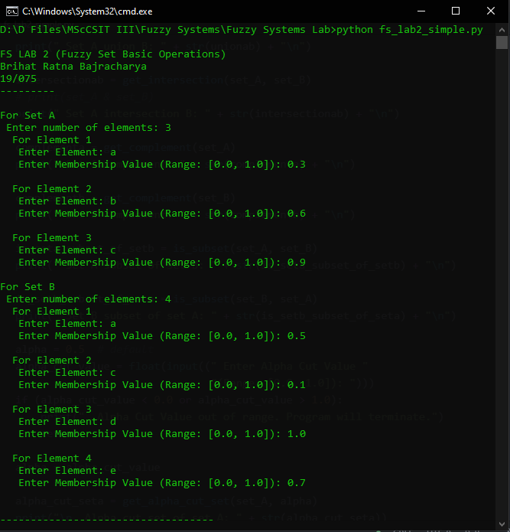Figure 1: Implementation of Fuzzy Sets and Operations (1/2)
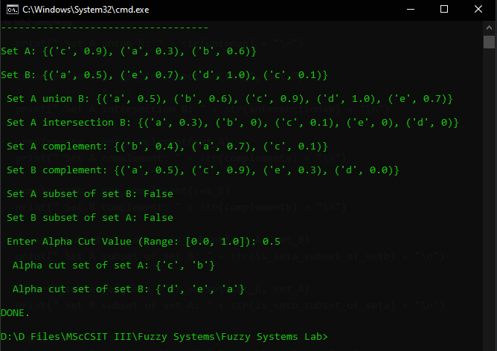Figure 2: Implementation of Fuzzy Sets and Operations (2/2)

Github Link
https://raw.githubusercontent.com/Brihat9/FS/master/fs_lab2_simple.py

